- Where would you find the address of the project in a set of plans?
- Where would I find the total building area?
- Where do you find information about the flood zone?
- How would you find out how many rooms there are in a building?
- How would I find out if the building is ADA compliant?
- Where do I find the designer’s information in a set of plans?
- What are my options to find what kind of materials the roof is made of?
- Where can I find information about the wall assembly?
- Where would I find information about the plants that I am to install?
- How can I tell if Air Conditioning Units are used in the building?
- Where does the architect put instructions on how something is to be fabricated?
- Where would I find information about what handrails are to be made of?
- Where would I find the dimensions of the exterior wall assembly?
- Where would I find information about irrigation for plants?
- How do I find out how many parking stalls there are?
- Where do I find information about inspection requirements?
- What is a storm door? How Is it different than a regular entry door?
- Where would I look in the plans to figure out where the project is located in a
particular part of town?
- What is a reflected ceiling plan and how can it be used to purchase the right number of fixtures?
- Where would I find information about the concrete dimensions on the ground level of the building?
- How can I discover how tall a building is? (Hint: one is for the code reviewer, and the other location is for the builder)
- Where would I expect to find the names of the plants that are to be planted at the project?
What is a plumbing schedule? Can there be more than one listed in a drawing?
- Identify these symbols:
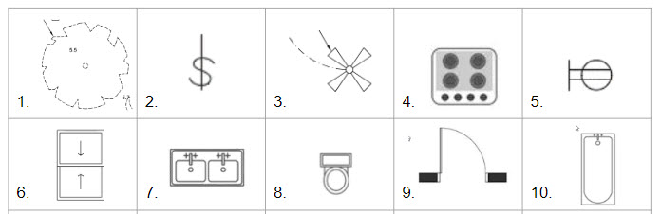
1.
2
3.
4.
5.
6.
7.
8.
9.
10.

- What is the difference between an isometric plumbing plan and a one line electrician diagram?
- What is a change order? What causes a Change Order?
- What is the Construction Specifications Institute?
- What is the CSI Masterformat?
- What is the difference between a direct cost and indirect cost when estimating a construction project?
- Define HVAC in construction.
- What are the differences between low voltage, Medium Voltage and High voltage electricity systems?
- What role does the architect serve on the construction team? What role does the Project engineer serve? Superintendent?
- What is the Uniform Drawing System ? How does plan organization correlate to the Letters next to page numbers?
- What is a request for proposal?
- What is a Request for Information?
- What is the Owner Architect Contractor Meeting?

